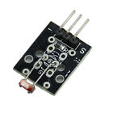**For Arduino AVR PIC Photoresistor Photo Resistor Module**

* 100% brand new and high quality
* Introduction
* Photoresistor in our daily lives but also be able to see, is mainly used in smart switch, giving our students Live brings some convenience, but, in our daily electronic design will also be used. Then in order to make better use,We have the appropriate module, easy to use, and efficient.
* Overview
* Photoresistors are semiconductor photosensitive devices, in addition to having high sensitivity,fast response, consistent with the spectral characteristics and value of good features, but at a high temperature, and humidity in harsh environments, but also to maintaina high degree of stability and reliability, wide pan used cameras, solar garden lights, lawn, detectors, clock, music, cups, gift boxes, mini-Night light, light voice switches, lights automatically switch toys and a variety of light control,light control lighting, lamps and other light automatic opening OFF control field
* Main parameters and characteristics
* According to the spectral characteristics of the photoresistor has three photoresistor: Ultraviolet photosensitive resistance, infrared light-sensitive resistors,Visible photosensitive resistance;
* The main parameters are as follows:
* Dark current, dark resistance: photosensitive resistance at a certain applied voltage, when the light is not irradiated when the flowing Current is called dark current. Applied voltage and dark current ratio as the dark resistance;
* Sensitivity: Sensitivity is irradiated by light sensitive resistor, the resistance value (dark resistance) when irradiated with light Resistance value (light resistance) the relative change in values.
* Volt-ampere characteristic curve.Voltage characteristic curves are used to describe the resistance of the applied voltage and the photosensitive photocurrent relationship,On the photosensitive devices, the light current with applied voltage increases.
* Temperature coefficient. Photoelectric effect photoresistor affected by temperature, at a low temperature portion photoresistor photoelectric Sensitive high sensitivity at high temperatures is low.
* Rated power. Photosensitive resistor rated power is allowed for certain lines in the power consumed when the temperature rise High, its power consumption is reduced.

How to corresponding wiring?

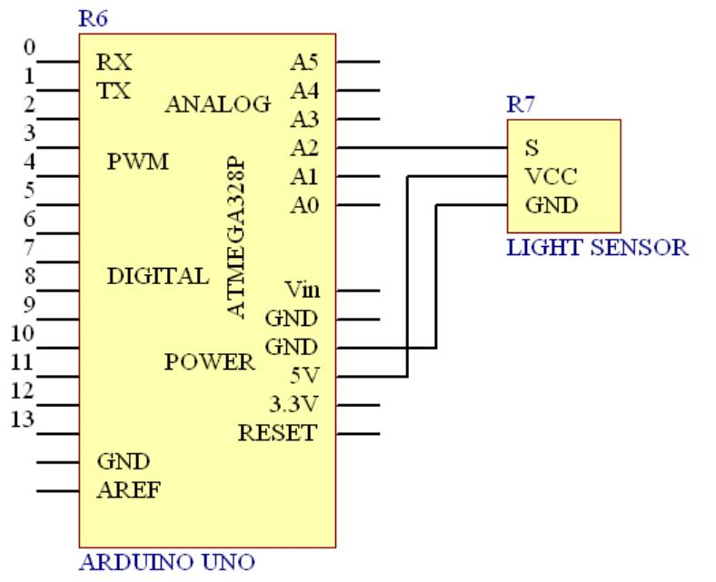

Test code:

int sensorPin = 2;

int value = 0;

void setup() {

Serial.begin(9600);

}

void loop() {

value = analogRead(sensorPin);

Serial.println(value, DEC);

delay(50);

When there is light , the output voltage is high , the equivalent of the switch is turned on, but there is no light , the output voltage is low , the equivalent of switching off

Compared to the output data （Bright and dull ）

